Use Case 1 Student Guide: New York's Energy Mix
Oct 29, 2026 · @Sid Raut

The challenge
Where does New York's electricity come from, and how does the mix of energy sources change over time?
Your team gets three years of real generation data from the New York Independent System Operator (NYISO), the organization that runs the state's power grid. In about five hours you will turn it into a visual tool and explain what it shows.
Why it matters: New York's climate law calls for 70% renewable electricity by 2030 and a zero-emission grid by 2040. Before anyone can judge progress, they need to see clearly where power comes from today and how fast that is changing.
A successful team will:
- Calculate each energy source's share of generation, in percent
- Show it in at least one clear, working visualization
- Explain two findings with numbers behind them
- Demo the result in about three minutes
No website, live data feed or API is required. A well-built spreadsheet chart is a complete Minimum entry.

Choose your level
Every team must finish the Minimum deliverable first. Move up only once it works.
Level | Project | You must deliver | Best data file
Minimum | Basic energy mix chart | One working chart of % generation by fuel; percentage calculations shown; two observations; a brief demo | Monthly
Intermediate | Interactive energy dashboard | Charts or filters that compare months, seasons, days or hours, and explain what changes | Daily + hourly profile
Advanced | Energy mix and emissions analyzer | Estimated CO₂ using the supplied factors, plus at least one what-if scenario comparing mixes | Monthly or daily + emissions factors

The dataset
You get NYISO's real-time fuel mix for Jan 1 2023 to Dec 31 2025, cleaned and pre-aggregated so it opens in Excel or Google Sheets. Nothing is missing: every one of the 26,304 hours has a reading for every fuel.
File | Rows | One row is | Use it for
nyiso_fuel_mix_monthly_2023_2025.csv | 36 | one month | Shares by year or month (start here)
nyiso_fuel_mix_daily_2023_2025.csv | 1,096 | one day | Seasons, weekdays vs weekends, extreme days
nyiso_hourly_profile_by_month_2023_2025.csv | 864 | one hour of an average day in a month | How the mix shifts from night to evening peak
emissions_factors.csv | 7 | one fuel | Advanced level CO₂ estimates
The full column list is in Data_Dictionary.docx.
Units. NYISO measures power in MW (megawatts, a rate, like speed). Energy is MWh (megawatt-hours, an amount, like distance): 1 MW running for 1 hour = 1 MWh. The daily and monthly files are in MWh; the hourly profile is average MW. 1,000 MWh = 1 GWh and 1,000,000 MWh = 1 TWh. New York's grid generated about 133 TWh in 2025.
The seven fuel categories, as NYISO labels them:
Category | What it is | Fossil?
Dual Fuel | Plants that burn natural gas but can switch to oil; mostly in New York City and Long Island | Yes
Natural Gas | Plants that burn only gas, from efficient combined-cycle units to peakers | Yes
Nuclear | Nine Mile Point, FitzPatrick and Ginna, all upstate | No
Hydro | Dams, led by NYPA's Niagara and St. Lawrence–FDR projects | No
Wind | Grid-connected wind farms | No
Other Renewables | Other grid-connected renewables such as utility-scale solar and biomass | No
Other Fossil Fuels | Oil or kerosene units; usually under 1% | Yes
Know the limits before you present.
- The data covers generation inside New York. Power imported from Canada, New England, PJM and other neighbors is not in it.
- Rooftop and other behind-the-meter solar is not in it either, so solar's real contribution is larger than "Other Renewables" shows.
- Generation is not the same as consumption. Say "generated in New York", not "used in New York".

Your five hours
Have a working Minimum chart by the 1:30 checkpoint. Teams that skip this step often reach the demo with nothing that runs.
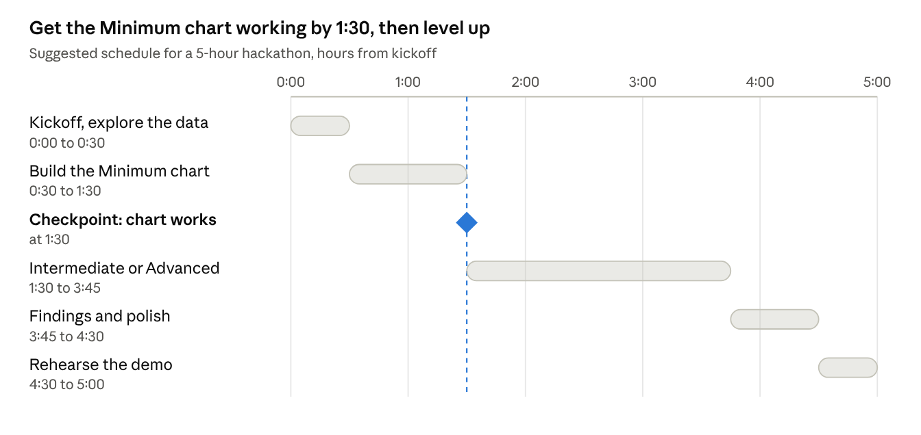
suggested schedule · 5 hours, 1 checkpoint
Split the work so nobody waits on anyone else:
Role | Owns
Data lead | Loading the files, totals and % calculations; checks shares add to 100%
Visualization lead | Charts, labels, colors, filters
Analyst | Finding the story: comparisons, extremes, the two observations, emissions math
Presenter | The 3-minute demo script and timekeeping; joins whichever role is behind
Teams of three can merge Analyst and Presenter.

How to build each level
Your team chooses the tools. We provide the data; how you analyze and present it is up to you. Spreadsheets (Excel, Google Sheets), Python or R, and BI tools (Power BI, Tableau, Looker Studio) can all reach the Advanced level. Pick what your team already knows, so your time goes into the analysis rather than learning a tool.

Minimum: basic energy mix chart
- Open nyiso_fuel_mix_monthly_2023_2025.csv and keep the 12 rows for one year.
- Sum each fuel column to get that year's MWh per fuel, and sum those for the year's total.
- Calculate each share: fuel MWh ÷ total MWh × 100. Check the seven shares add to 100%.
- Chart the shares. A sorted bar chart is easier to read than a pie with seven slices; label each bar with its %.
- Repeat for the other two years and compare.
- Write two observations. Each one names a number and says what it means.

Intermediate: interactive energy dashboard
Build on the Minimum chart, then add at least two ways to explore. Ideas:
- A stacked bar chart of all 36 months, with a switch between TWh and % share
- A filter for year, season or fuel
- The average day for a summer month vs a spring month (hourly profile file), showing which plants ramp up for the evening peak
- Weekday vs weekend fossil share (daily file, is_weekend column)
- The days with the highest and lowest fossil share, and what was happening then

Advanced: energy mix and emissions analyzer
- Join emissions_factors.csv to your totals using the fuel_column names.
- Estimate CO₂ for each year and month (method below).
- Calculate carbon intensity: tonnes CO₂ ÷ MWh generated.
- Build at least one scenario that moves energy between sources and compare the result to the actual year.
- Report a range using the low and high factors, not a single number.

Estimating emissions (Advanced)
Estimated CO₂ is each fuel's energy multiplied by an emissions factor, summed across fuels:
CO₂ (tonnes) = Σ over all fuels of ( fuel MWh × fuel emissions factor in tCO₂/MWh )
Each factor combines how much CO₂ a fuel releases per unit of heat (EIA CO₂ coefficients) with how much heat a typical plant needs per kWh (EIA 2025 average heat rates):
Fuel | Low | Central | High | Central assumes
Natural Gas | 0.399 | 0.399 | 0.581 | Gas in a combined-cycle plant (7,535 Btu/kWh)
Dual Fuel | 0.399 | 0.545 | 0.765 | Gas in an older steam plant (10,293 Btu/kWh)
Other Fossil Fuels | 0.765 | 0.765 | 0.975 | Distillate oil in a steam plant (10,319 Btu/kWh)
Nuclear, Hydro, Wind, Other Renewables | 0 | 0 | 0 | No combustion emissions
Factors are in tonnes CO₂ per MWh. With the central factors, New York's grid emitted about 33.5 million tonnes in 2025, or 0.251 t per MWh. Check your own math against that.
These are assumptions, not measurements. Real plant emissions depend on which units ran, how efficiently, and whether dual-fuel plants burned oil. Say so in your demo, and show how your answer moves between the low and high factors.
Scenario ideas. Each moves energy from one source to another at that source's average factor:
- 10 TWh of new wind replaces dual-fuel generation
- A nuclear unit producing about 8 TWh a year retires and natural gas fills the gap
- A wet year adds 4 TWh of hydro and cuts the same amount of gas
Real grids balance supply and demand hour by hour, so a yearly swap is a simplification. Treat results as an order-of-magnitude estimate.

Demo and judging
You have about three minutes. Cover, in order: the question you asked, the data you used, the chart (live, not a screenshot), your two or more findings, and one limitation of your analysis.
Criterion | Weight | What judges look for
Data & Technical Execution | 30% | Accuracy of analysis, soundness of methodology, appropriateness of assumptions and overall technical rigor.
Visualization & Insights | 20% | Clarity and effectiveness of visualizations, whether key insights are immediately apparent, appropriate chart selection, dashboard usability, and ability to answer the business question at a glance.
Innovation, AI & Automation | 15% | Creative use of analytics techniques, AI/GenAI capabilities, machine learning, automation of data ingestion or processing, and innovative approaches to solving the problem.
Potential Business Impact | 15% | Practical value of the solution, applicability to real-world challenges, scalability, or decision-making impact.
Demo & Storytelling | 20% | Clear and compelling presentation, logical flow, effective communication of findings, ability to explain technical concepts, staying within time limits, and engaging delivery

Before you present, check:
- ☐ One working visualization
- ☐ Percentage calculations shown, adding to 100%
- ☐ Two observations, each with a number
- ☐ Data source and time period stated on the chart or slide
- ☐ (Advanced) emissions factors and their range stated

Questions to explore
Stuck for a finding? Each of these has a real answer in the data.
- Which single source is largest? How much do natural gas and dual fuel supply together?
- Wind grew every year from 2023 to 2025. Did the zero-carbon share grow with it? If not, which source fell?
- Which month has the highest fossil share, and why would that month need more gas?
- Nuclear output is flat most of the year but drops for a few weeks in spring and fall. What causes those dips?
- How different is a hot July afternoon from a mild April afternoon, hour by hour?
- Are weekends cleaner than weekdays? By how much?

Common mistakes
- Adding MW from the hourly profile to MWh from the daily file. They measure different things; keep them separate.
- Shares that don't add to 100%. Usually a missing fuel column or a total from the wrong rows.
- Comparing totals across months of different lengths. February has fewer days; use % shares or daily averages.
- Calling it New York's "consumption". It is generation inside the state; imports are not included.
- A seven-slice pie chart. Sorted bars are easier to compare.

Sources
- NYISO real-time fuel mix, report P-63: the 5-minute data behind every file in the kit
- EIA carbon dioxide emissions coefficients: CO₂ per million Btu by fuel
- EIA average heat rates by prime mover and fuel: Btu per kWh by plant type (2025 values used)

